New Evaluation State Reports
To Update the Report
- Take the option Special Report Selections
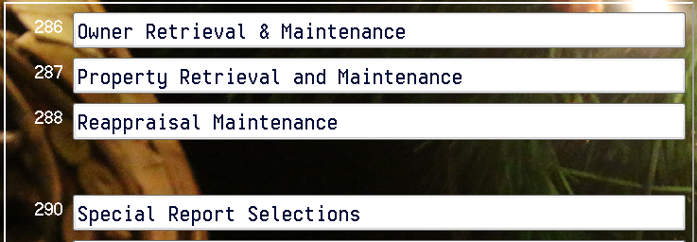

- Modify the report you normally run for the evaluation – for example acreage amounts 10 and above
- Click File Type
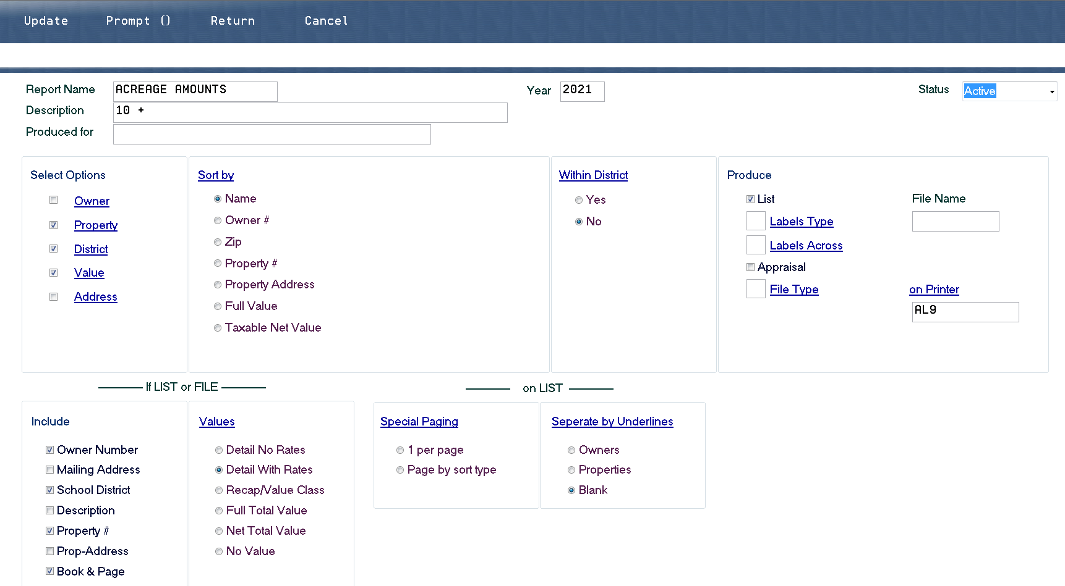

- Select Evaluation Property List
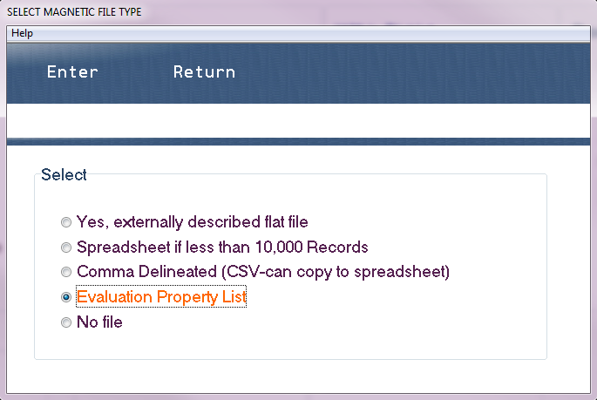

- Press enter
- Key in a File Name ( Must start with a letter, not have spaces
or special characters)
- Uncheck List
- Make sure owner number and property # are checked
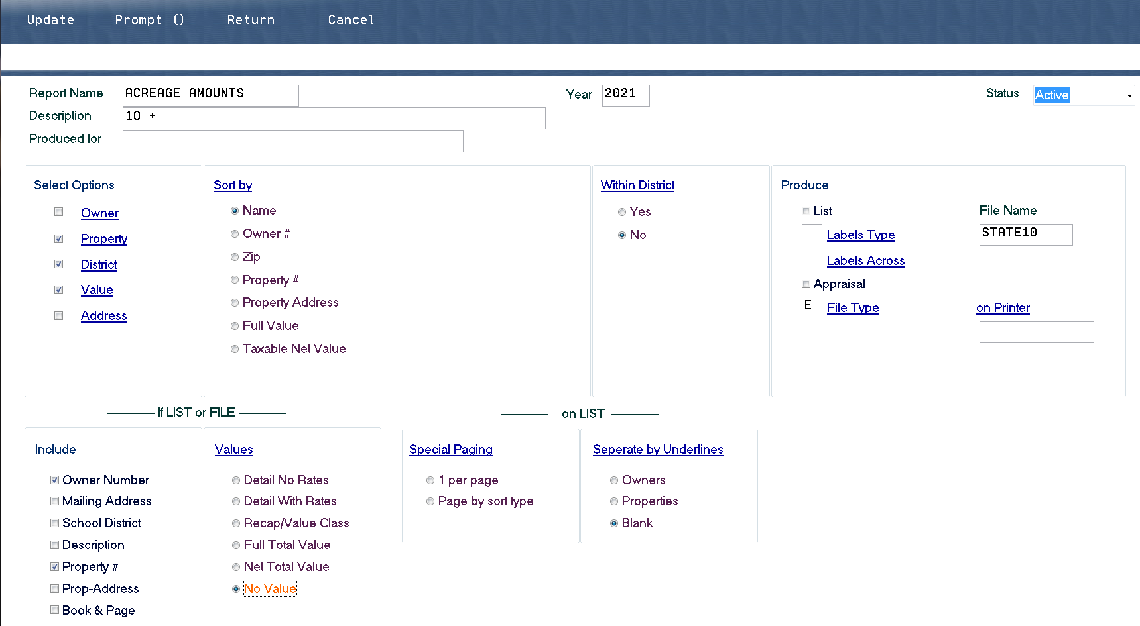

- Press update

To Run the Report
- Select your report and press Print
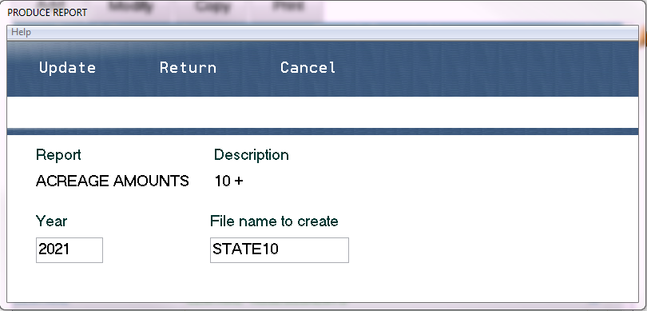

- Press Update to Run
- When the file is done Processed will show up next to the
report name
- Open markh and you will see a spreadsheet created with your report name. It will only contain owner and property codes. Upload this for your evaluation.

